EXAMPLE Proposal for Marine and Oilfield
Oily Waste Treatment Plant

Capacity 2 to 15 m³/hr

General Proposal for Client Review Purposes

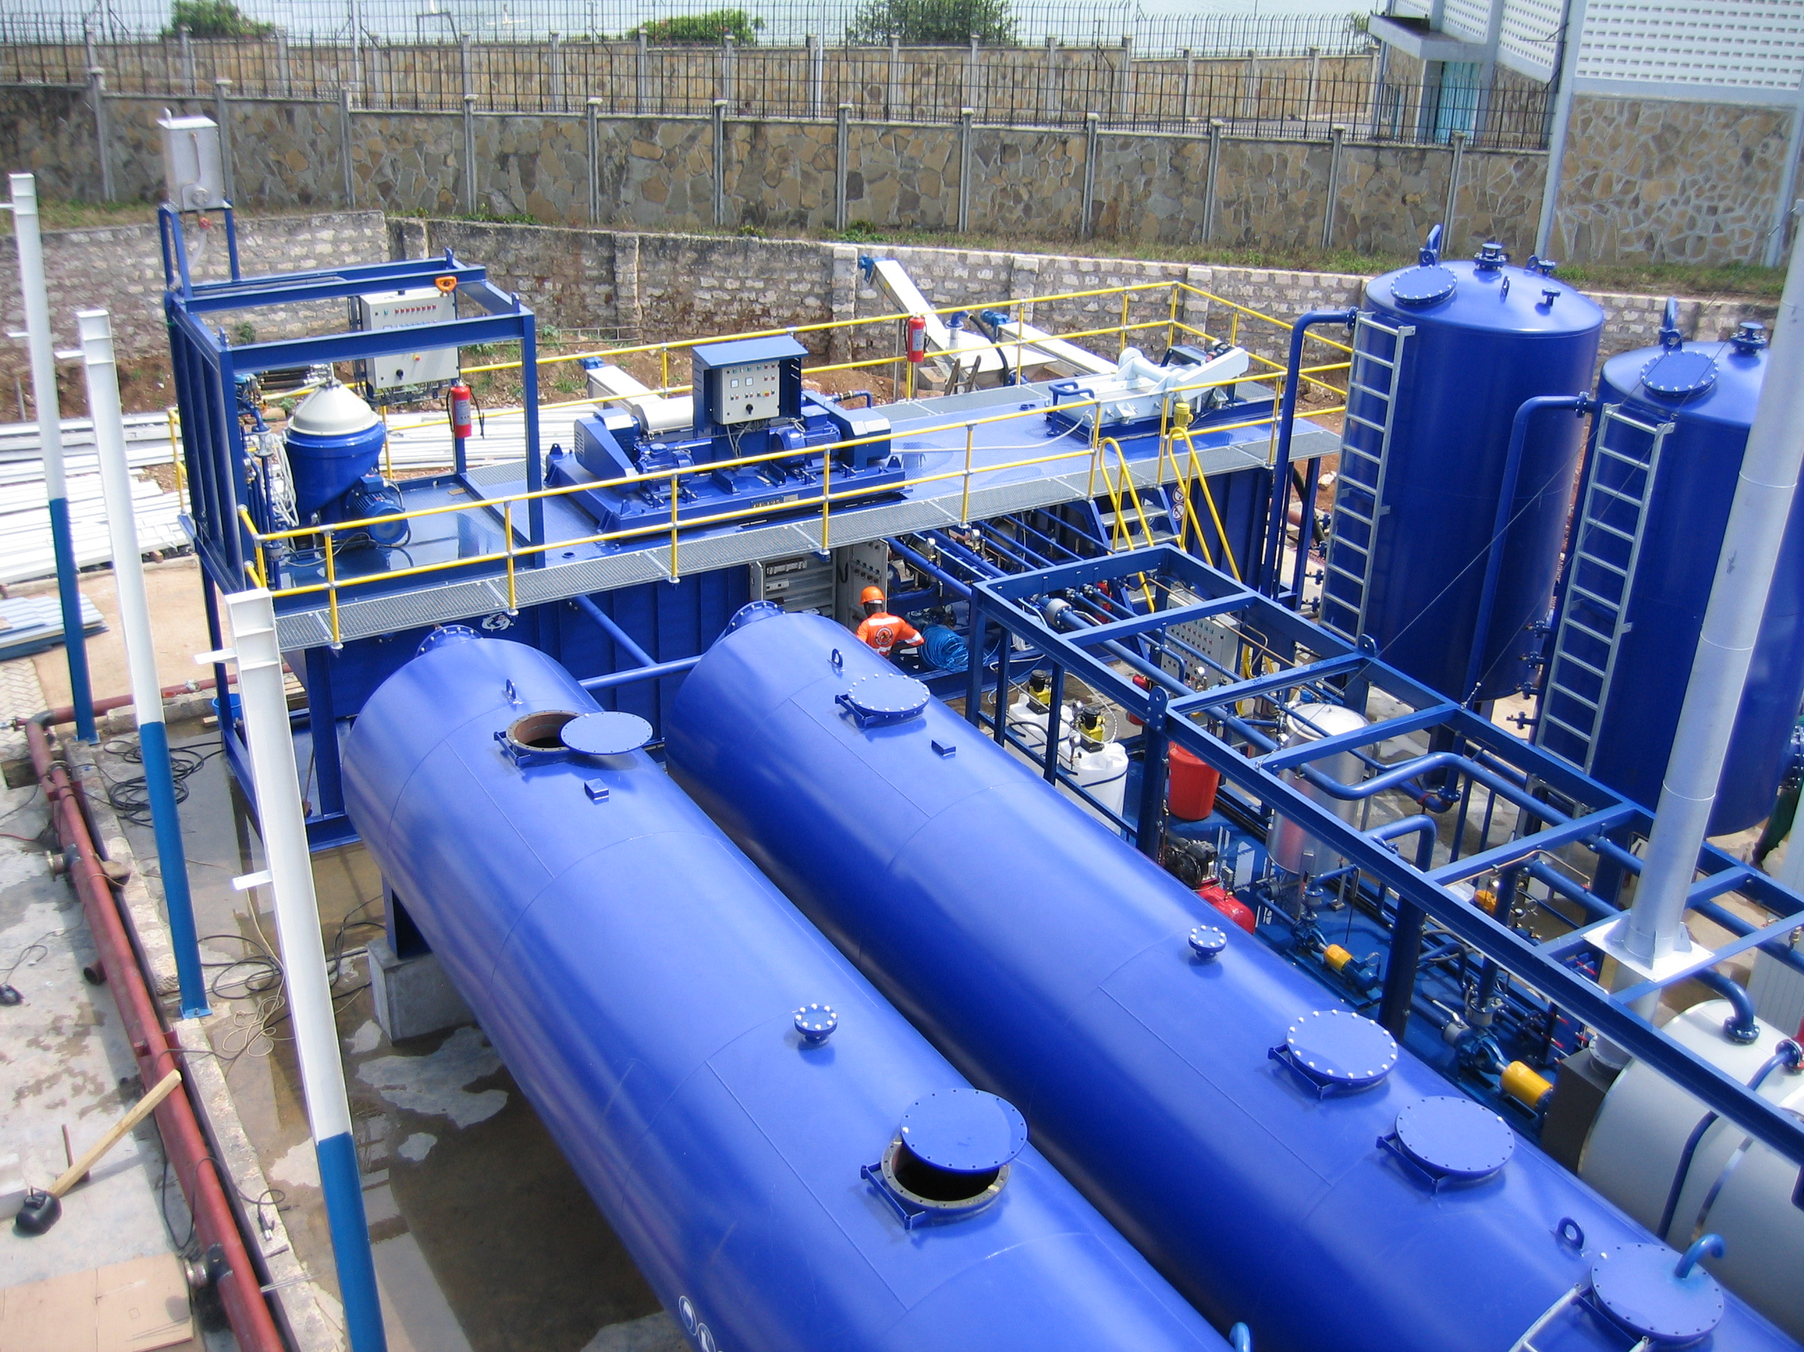
Photo of Plant undergoing Installation

Introduction

G-force specializes in the manufacture of plants for treatment of hazardous oily waste by-products from the shipping industry (Marine Waste) and the Oilfield Industrial sectors of drilling, production and refining.

The plants we manufacture are designed to receive and treat all forms of oily waste from produced water to polluted soil. Most of our main applications involve the treatment of refinery slops & sludges, oil storage tank bottoms and marine bilge, slops & sludges.

G-force is unique in that we offer declassification solutions for all three of the separated phases: oil-water-solids. Oil is the simplest because it is a fully recyclable material suitable for return to the client or to market. Water is treated to be re-used in the process and/or to meet environmental authority regulatory specifications so that it is recycled to back nature. Solids, representing the minimized waste, are further treated to meet USEPA, European or the environmental authority specifications for declassification where a G-force plant is installed. In most cases where oily waste has been dumped into unlined earthen pits one of the main environmental requirements is to treat the underlying oil contaminated polluted soil once all the liquid waste has been excavated and treated. This service is too provided by G-force.

By offering these recycling and declassifying solutions G-force supports the Clients Waste Management Program to fulfil their environmental obligations with the local environmental authority.

This proposal in intended to give WEB visitors a preview of the technology we offer followed with our budgetary price. For Viewers interested to receive details specific to their actual type waste and waste volumes we kindly request you to contact us directly by completing our Oily Waste Questionnaire as provided on our WEB site. From this DATA we will reply with our recommendations of equipment and quote a firm cost to fulfil your scope of supply, including all details related to delivery times, shipping, site installation, commissioning and personnel training for operations takeover.

The process module
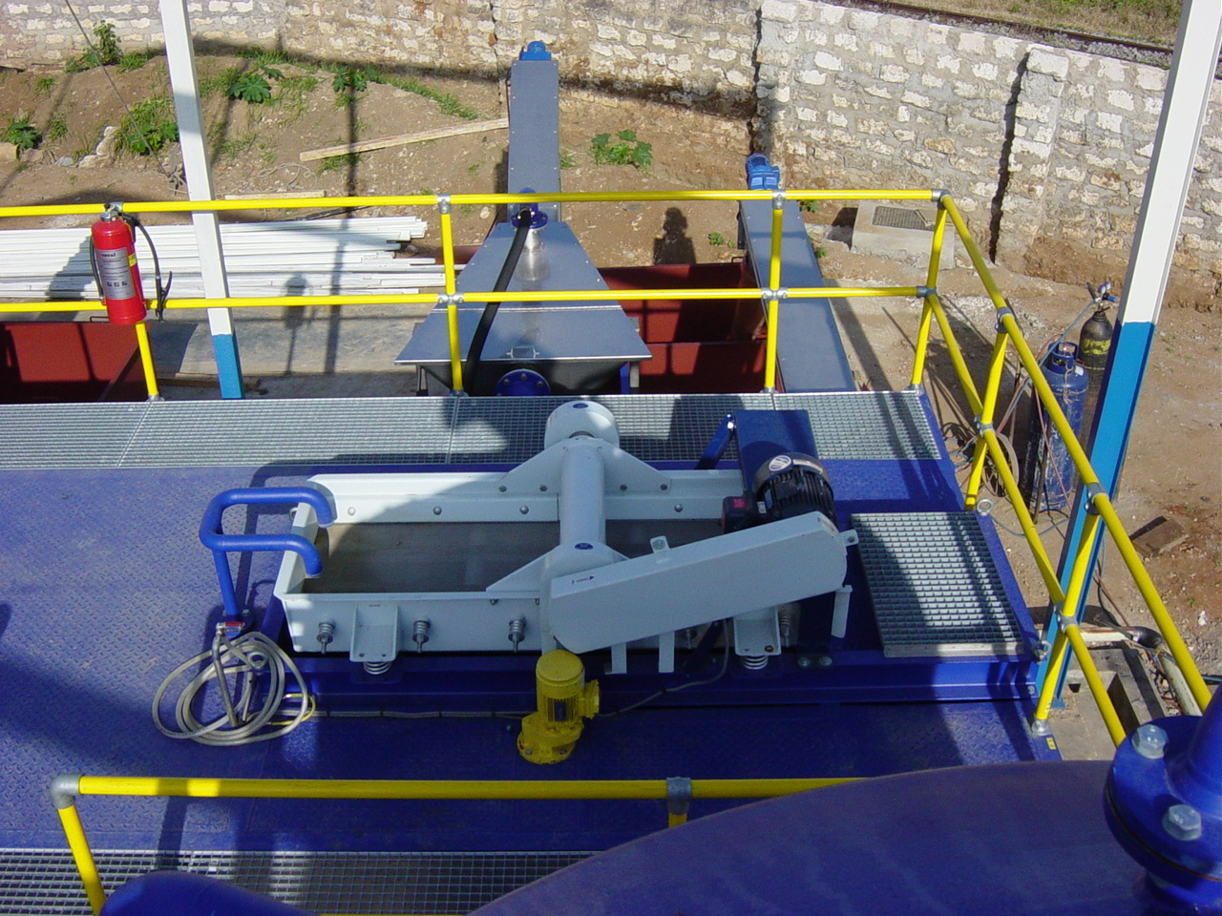
The main problem with oily waste is that the consistency is never the same. Even when treating slops from the same source the feed consistency changes from batch to batch. G-force treatment systems are designed with the flexibility to cope with these continuously changing feed materials. In most all cases the feed needs to be heated prior to treatment. Slop highly contaminated with sediment and debris must first be screened before they are fed to the installed Heat Exchangers. To begin the heating process the first batch of screened materials is pumped through a heat exchanger where the temperature is raised to ~50°C and after the heat exchanger the incoming balance of ambient dirty oily waste is mixed with the screened heated waste, this mixture is then pumped across a vibrating screen where all particles larger then the installed screen size are removed. The screened particles are collected in a screw conveyor and transferred into a waste bin. The liquid passing through the screen openings is collected in a dedicated tank situated directly below the Screen Separator. Agitators are installed in this tank to keep remaining solids in suspension and avoid stratification in the tank. From this tank the screened effluent (oil/water/sediment) is pumped through a 2nd Heat Exchanger to ~70°C and is fed into our 2-phase decanter. The decanter is capable of developing 3000-g and will remove up to 97% of the remaining solids down to a size of 5 microns. The solids separated in the decanter fall into a 2nd screw conveyor and are discharged into a waste bin. The separated decanter effluent (oil-water-solids) flow into a dedicated tank situated directly underneath the decanter. From the decanter tank the effluent is pumped through a 3rd Heat Exchanger where it is heated to ~95°C then fed into a 6000-g 3-phase Oil Purifying centrifuge where oil, water and the remaining sediments are removed in the final process. Clean oil is discharged under pressure and usually meets a specification of <0.5% to 2.0% BS&W. Water is discharged under pressure and normally requires further treatment in our API O-W Separator or our 12,000-g Water Concentrator 3-phase Centrifuge, or our DAF Unit (or all three) to reach its specification. Sediments are discharged into a dedicated tank and pumped into a drying conveyor. All solids removed (from the Screen Separator, Decanter and Centrifuge) are combined for final declassification.
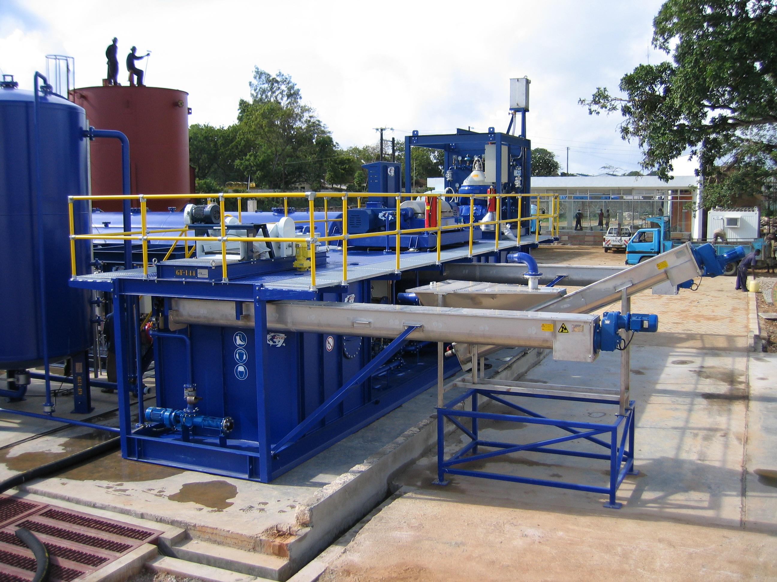

Vibrating screen
Main process module with Screw conveyors
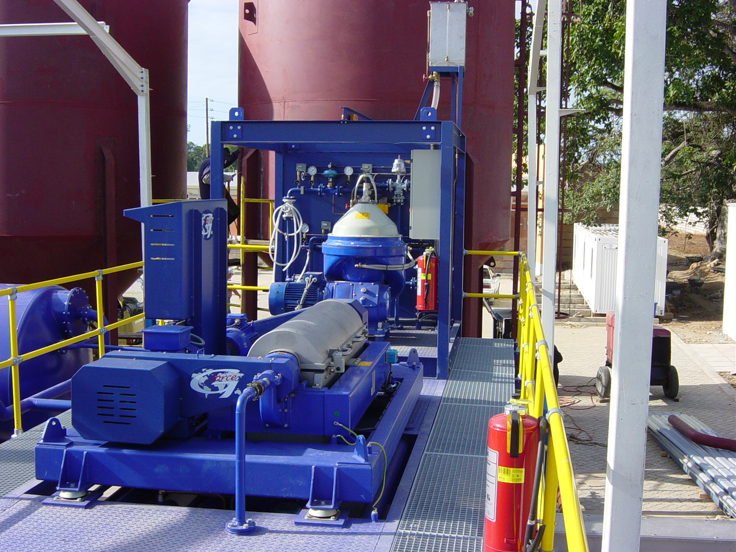
Front is Decanter - Back is Centrifuge

The utility module

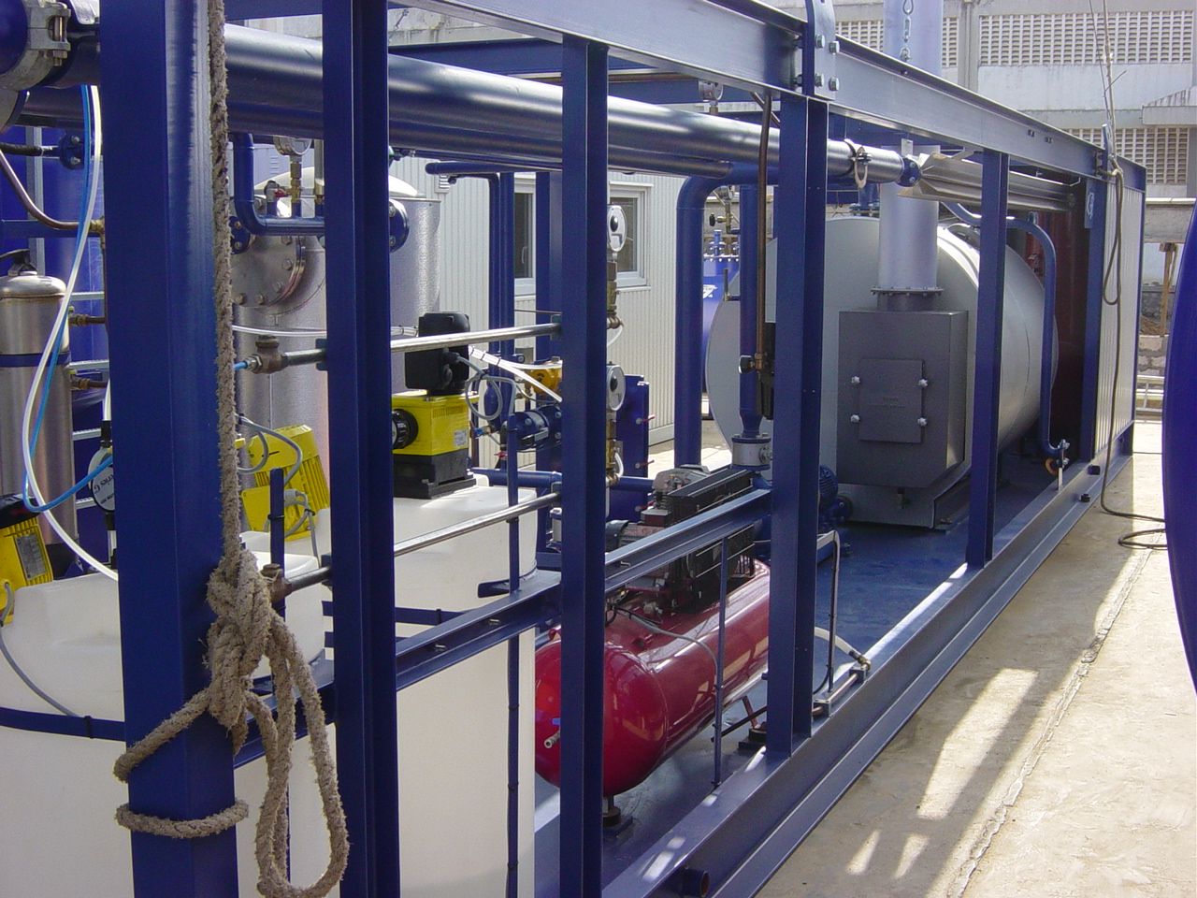
Important in the process for plant operations and to optimise oily waste separation is the requirement of heat, compressed air and hot fresh water. In most cases chemicals are required to break O-W emulsions. The utility module is set up for these requirements. The nature of oily waste requires the temperature in the Heat Exchangers is maintained at a minimum in order to avoid scaling. For this reason hot water (115ºC) is used rather than steam, also for safety and certification reasons a hot water boiler is preferred over a steam boiler. Another important reason for using hot water rather than a steam system is that once filled it does not consume water as the heating water is in a closed loop circuit. Chemical dosing systems are installed to apply de-emulsifiers. For operation of the 3-phase centrifuges hot fresh water is required to operate the solids discharge mechanism. A hot water buffer tank and circulation pump are installed to supply the process module with wash water where required. For the operation of various control valves in the system air is supplied by a compressor mounted in the utility module.
Utility module with boiler, compressor and chemical dosing stations

Optional equipment

The process module and the utility module are the minimum equipment required to process oily waste. There is however additional components that are required that G-force also delivers.

Feed buffer and cleaned product tanks

The system requires oily waste feed receiving tanks as well as treated clean oil & water holding tanks. G-force delivers a range of vertical and/or horizontal storage tanks. The tanks are sized to fit inside a standard ISO container for shipment. Maximum tank size that fit a 40’container is 40 m³. For treatment yards we recommended to have a feed holding capacity of 120 m³ (3x~40 m³ tanks) with 2x 20 m³ buffer tanks for treated oil and 2x 20 m³ buffer tanks for treated water.
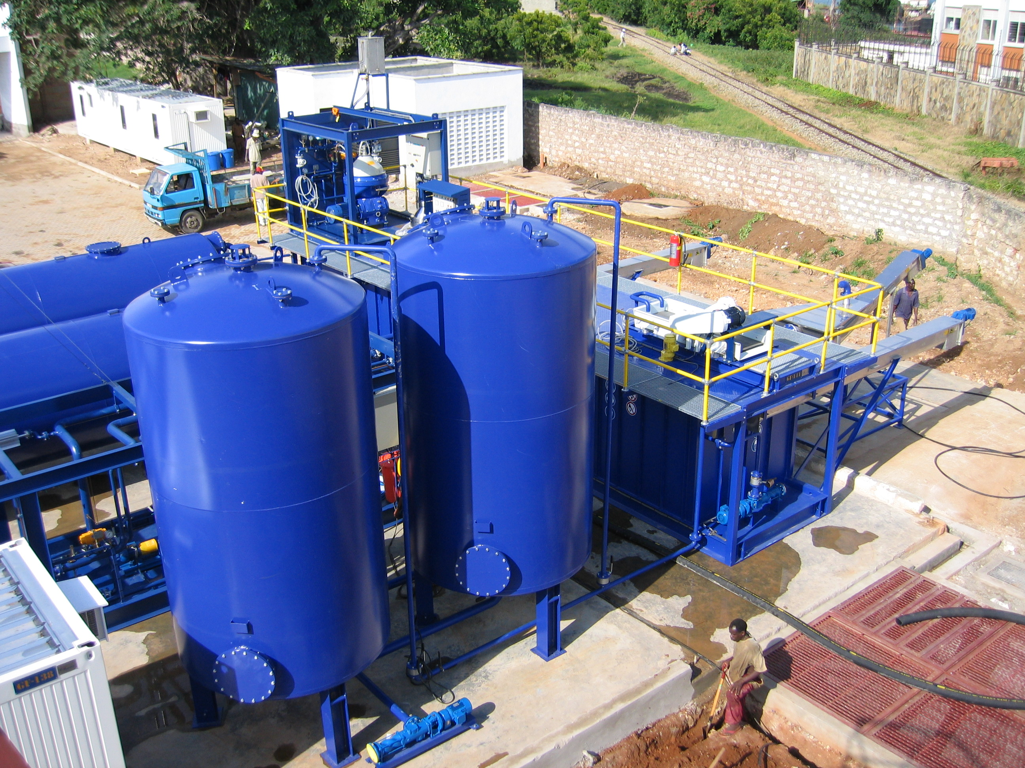
Storage tanks

API water de oiling separators
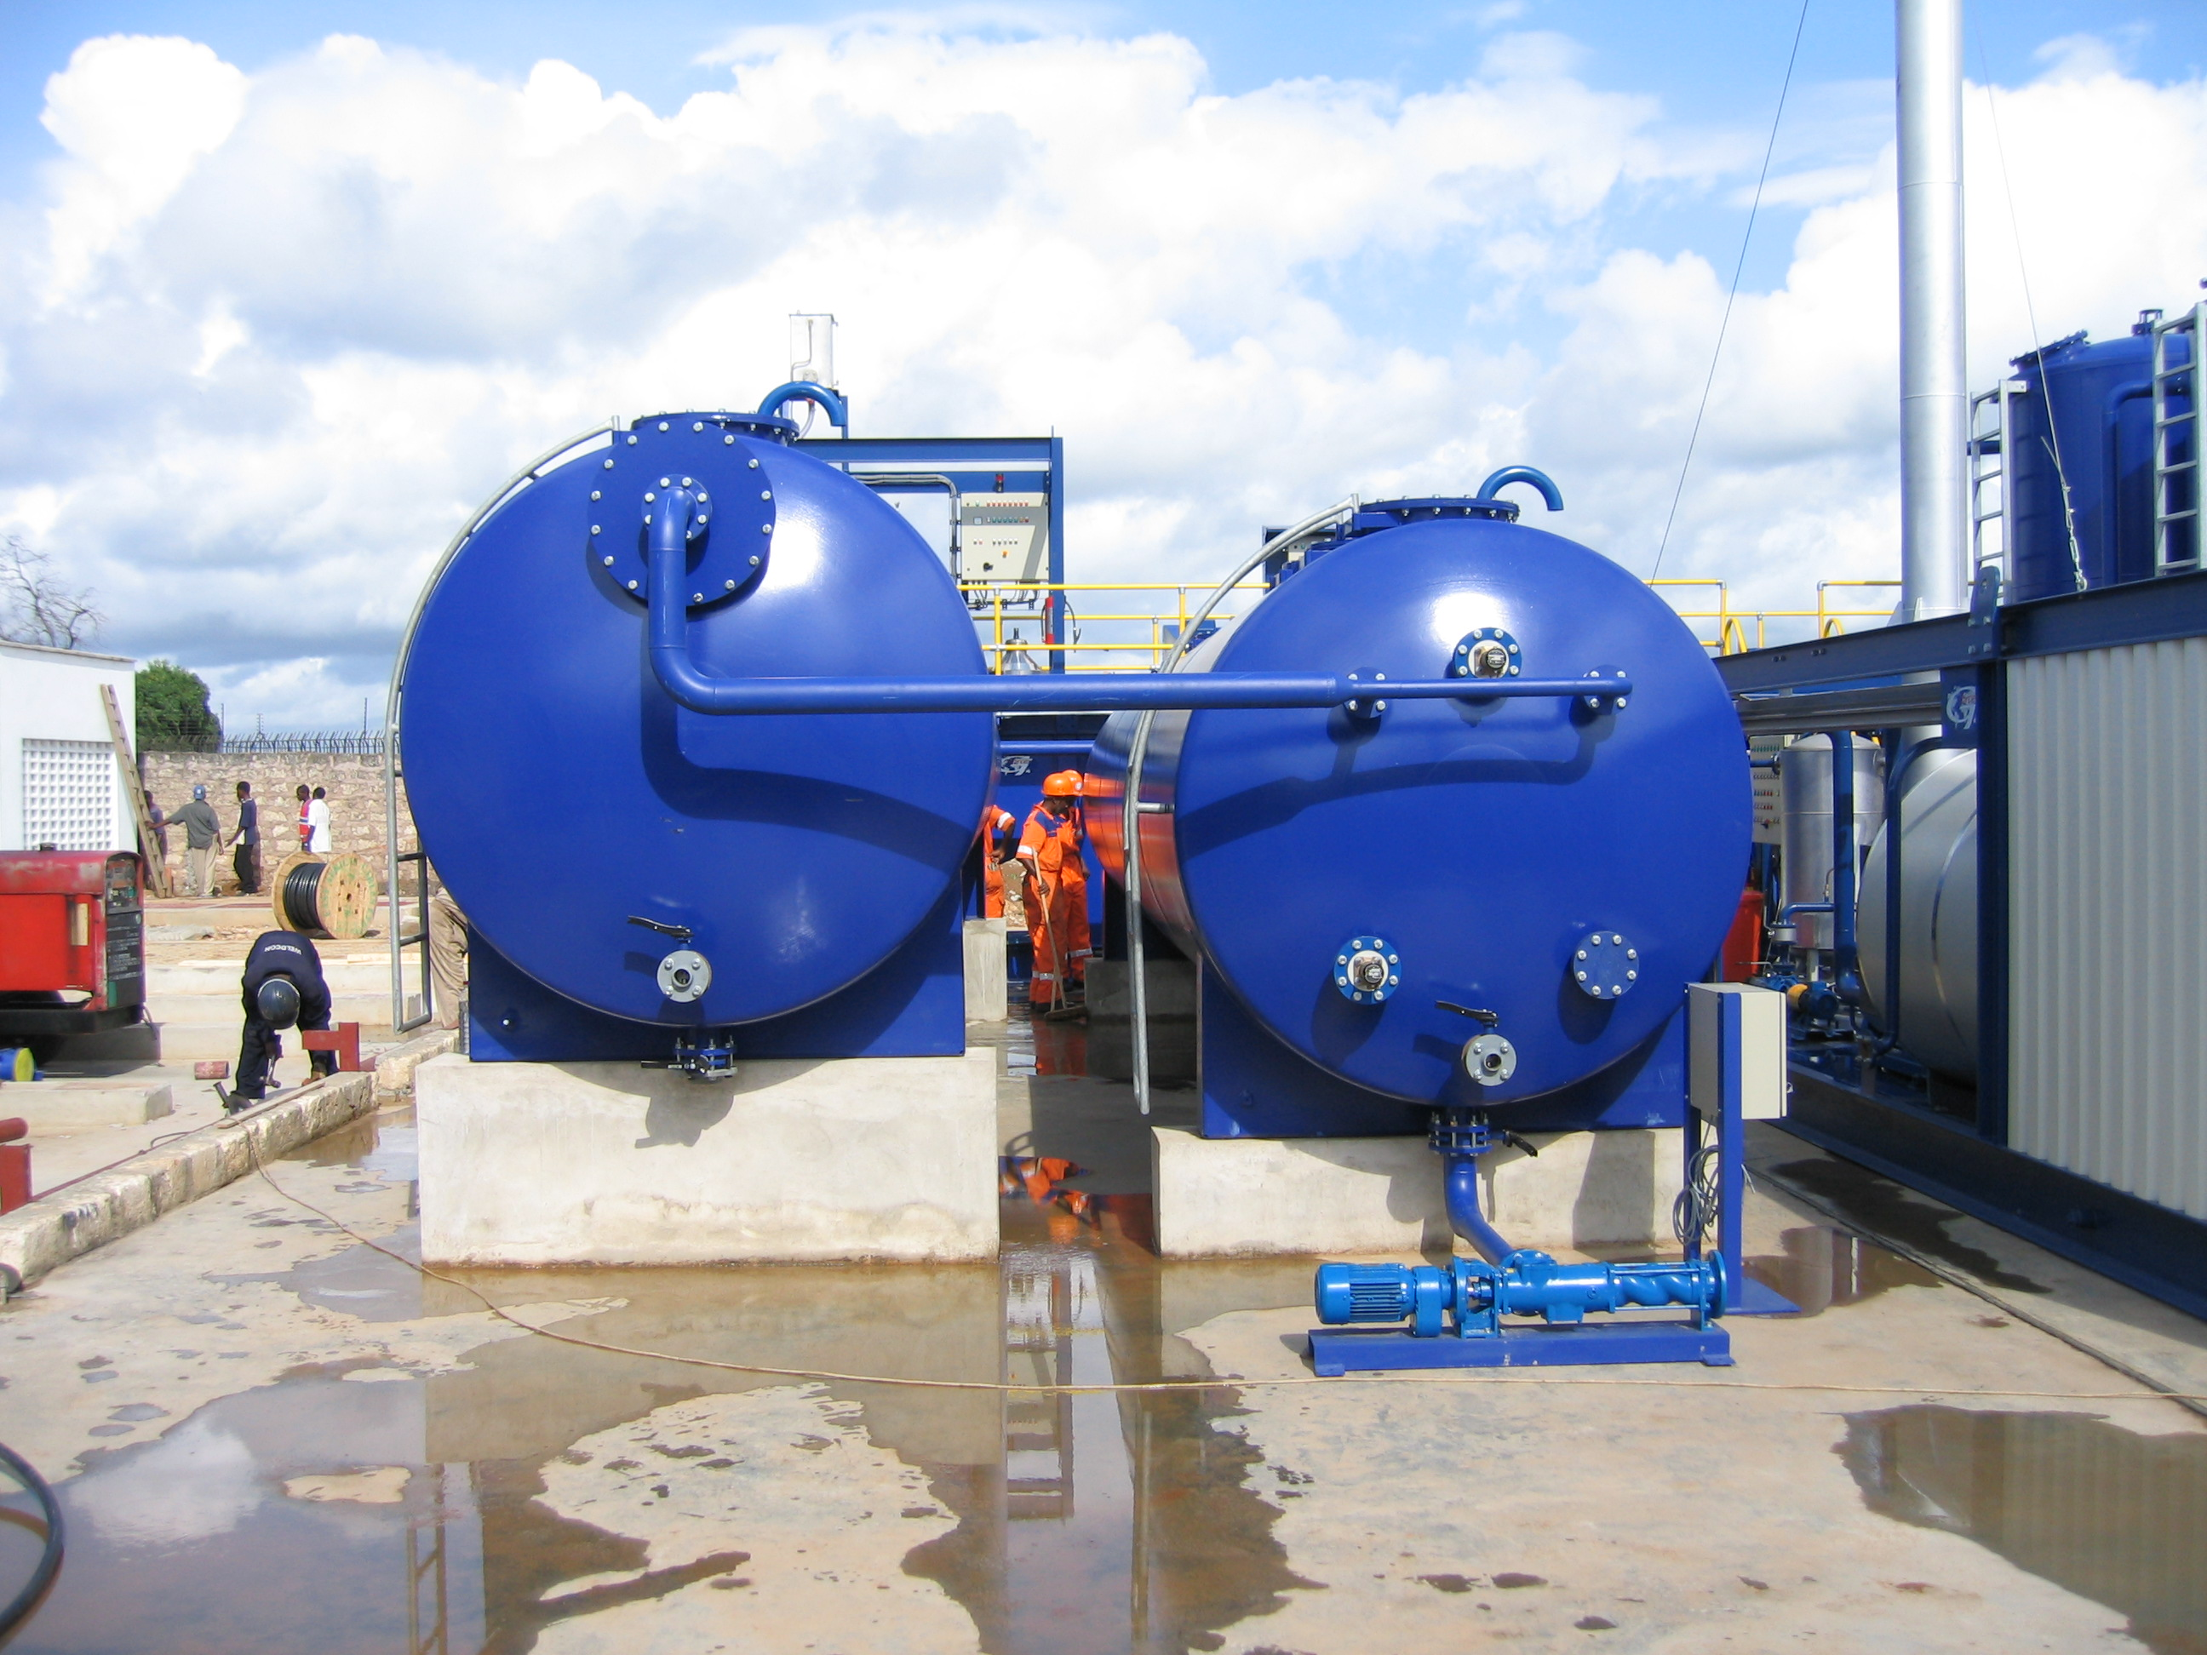
Water separated in the 3-phase Oil Purifying centrifuge generally needs further treatment in order to meet the required water specification. API separators are economical and the best low tech (1 g force) solution for the final treatment of water before feeding our 12,000-g water concentrating centrifuge followed by a DAF Unit. Water can then be returned to nature.
API water de-oiling separators

Laboratory module

A Facility dedicated to receive, treat, recycle and declassify oily waste is generally required to operate in strict compliance with the local environmental authority by testing and keeping materials balance records on all incoming waste and outgoing treated materials (oil, water and solids). In order to record and test daily the quality of the various incoming and outgoing phases a field laboratory is supplied to do field analysis. The laboratory comprises equipment and testing apparatuses such as: API lab centrifuge, oil density hygrometers, Dean Stark water in oil distillation apparatus, Soxhlet apparatus for determination of sediment content in various separated sediment phases, Viscometer to measure fluid rheologies, API Retort to measure % by Volume oil, water and solids, including all necessary laboratory glassware. The cabin is fully furnished with work counters, storage cabinets, wash sink, fume expeller, a Lab Technicians work desk, desk chairs, 3 double hinged windows and air-conditioning.
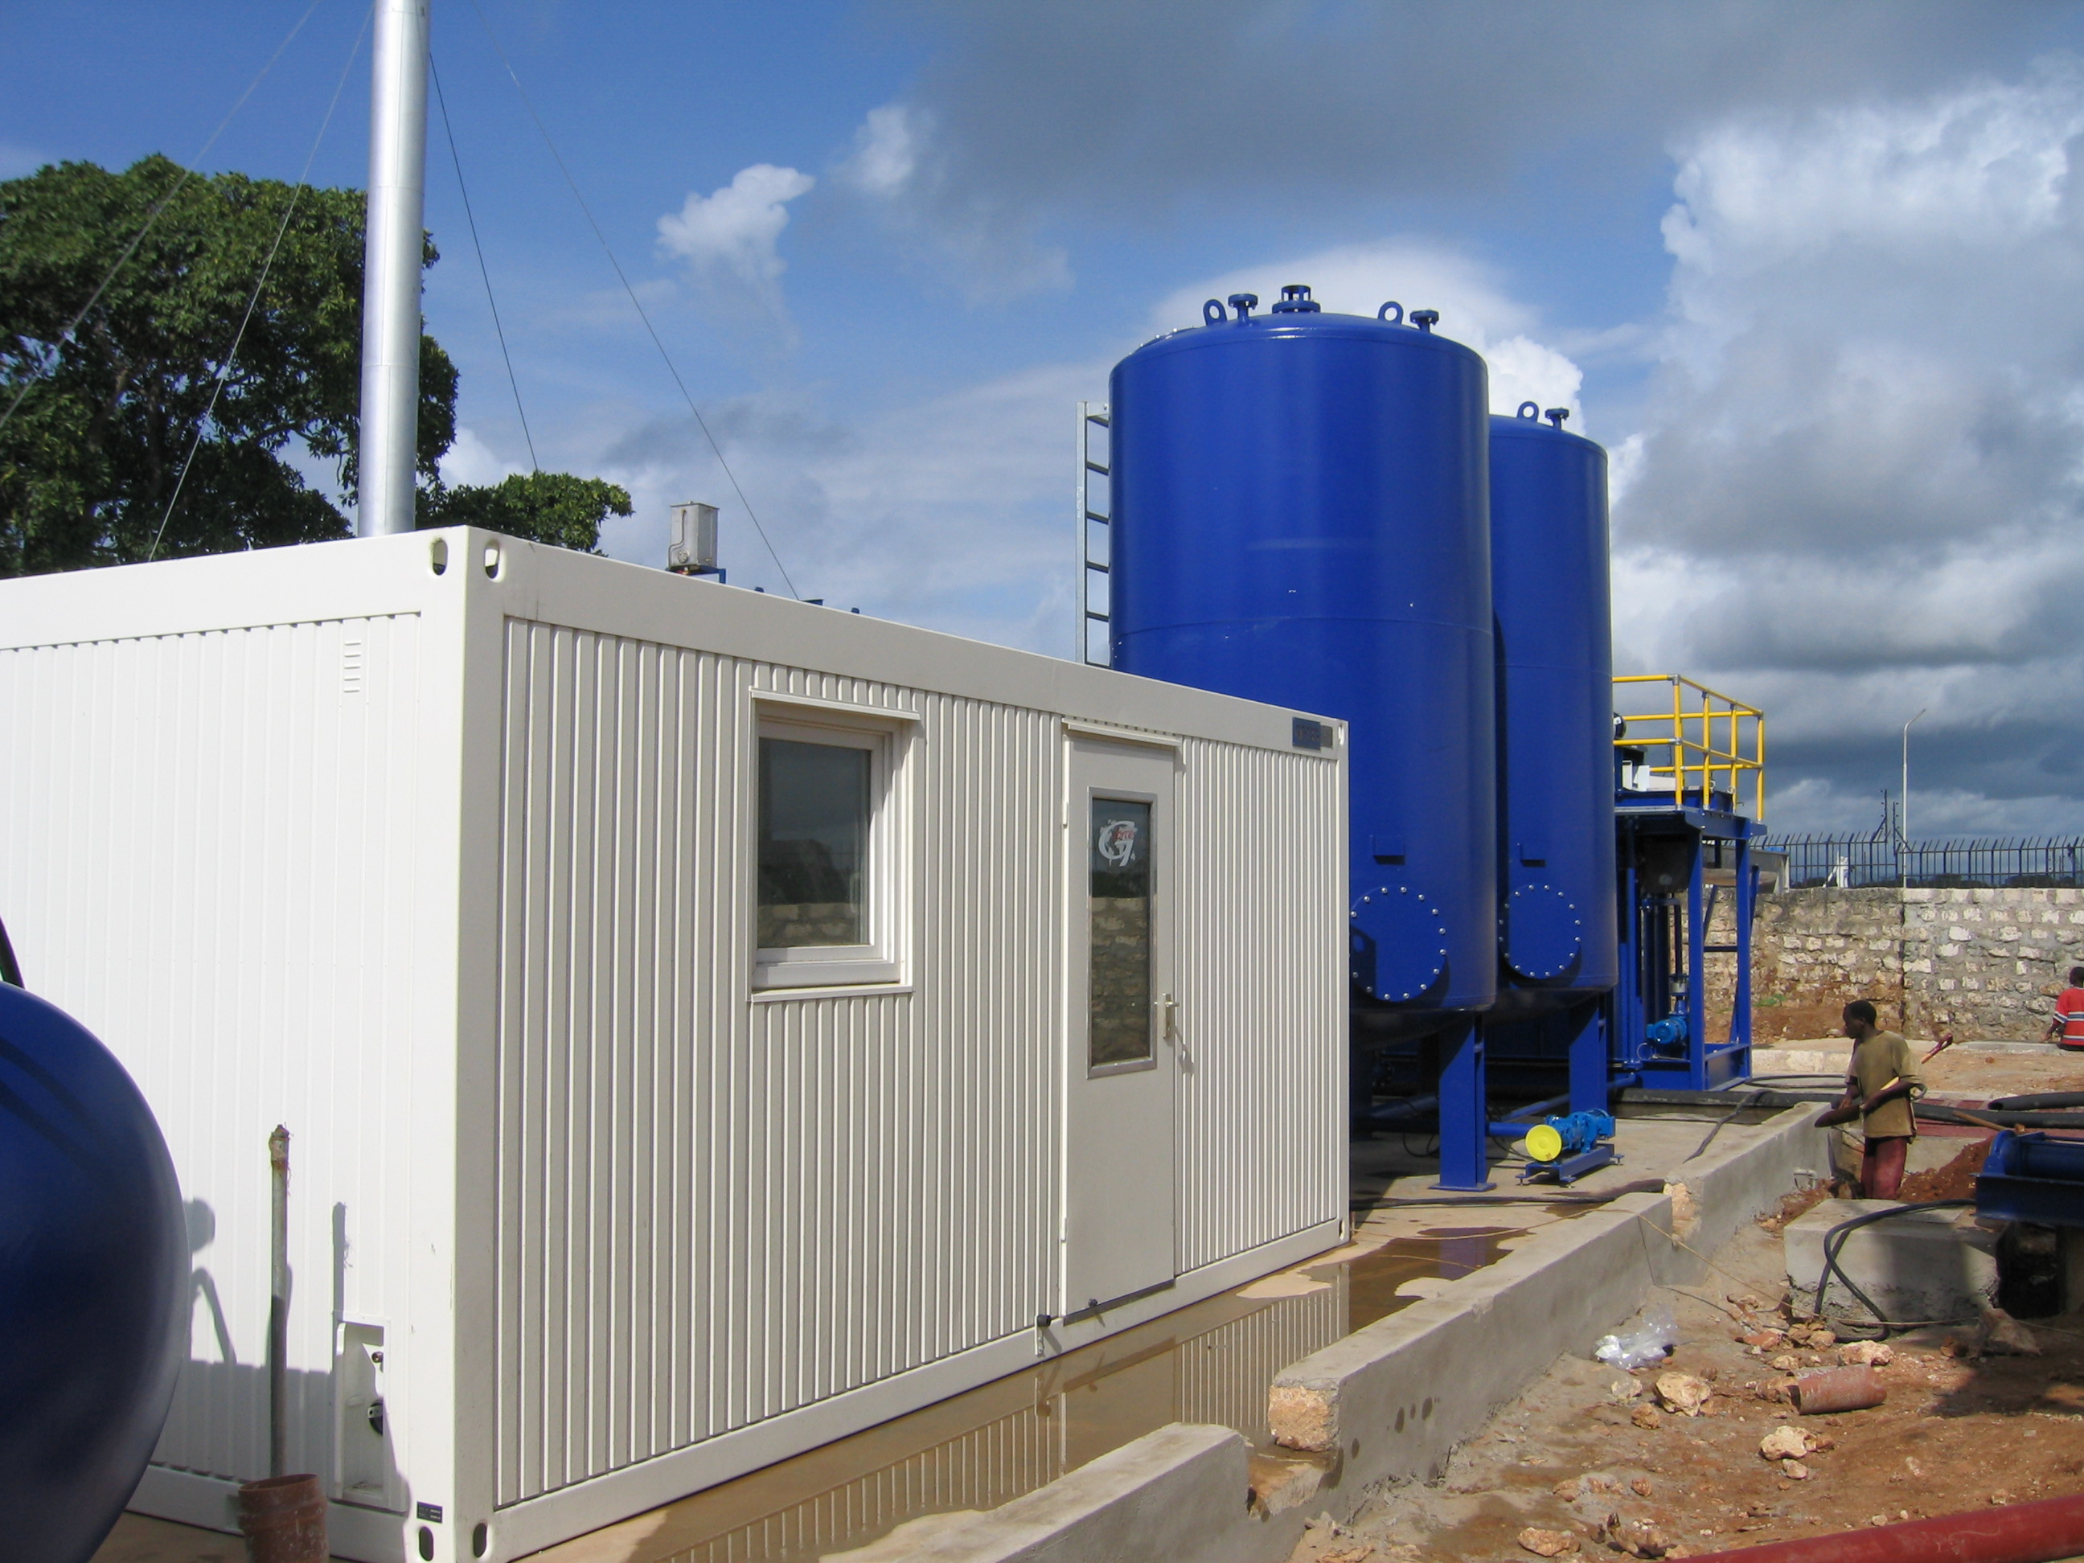
Field laboratory

General Comments

The G-force 2012 MKIIIFA Series Plant is fully automated so as to prevent operator error, reduce manpower, eliminate downtime and improve safety.

G-force is unique in that our base of experience allows us to deliver Clients complete plants, with all the peripheral equipment and supplies, delivered in one lot and immediately ready to lay down, plug-in and operate. This full supply eliminates all the add-ons generally observed in operations where the components have been purchased separately and the entire plant eventually piece mealed together. We also fully install and commission our plants to get them up and running for the client. The plant once delivered to the site is installed and commissioned in 10 to 20 days. Finally we train the client’s personnel to take over the operation of the plant as a contract commitment.

It should also be noted that all modules as quoted herein will fit in standard ISO containers so that shipping costs to any where in the world are minimized and the supplies are fully protected against damage and theft. Additionally transport can be done by conventional trucks with 40’ trailers and standard handling and lifting equipment.

Budget proposal

A. Main process module:

Consisting of:
Heat exchangers
Positive displacement pumps
Vibrating screen effluent tank
Decanter effluent tank
Three-phase separator sludge tank
3 x 40 m³ Process reaction tanks (heated, with agitators)
2-phase Vibrating screen
2-phase Decanter Centrifuge
3-phase Oil Purifying disc stack Centrifuge
3-phase Water Concentrating disc stack centrifuge
2 x 20 m³ Clean Oil Buffer Tanks
2 x 20 m³ Separated Water Buffer Tanks
API Oil-Water Separator
Chemical dosing system
Heating water manifold
Hot water wash and circulation system
Electrical control cabin, full plant automation (programmed)
Sediment screw conveyors
Utility equipment as required for the process

Total price Ex-works, fully assembled & factory tested Euro

B. Optional Supplies:

Available as:
Hot water boiler (Diesel fired or Electrical)
Site Laboratory Cabin fully stocked
40 m³ Waste Holding Tanks (single or in battery)
20 m³ or 40 m³ Treated Oil and/or Water Buffer Tanks
DAF Dissolved Air Flotation Unit
Solids Disposal Declassification system supply

Total price Ex-works, fully assembled & factory tested Euro

Budgetary price for full supply delivered & installed on site Euro

Note: If interested in a firm & complete offer please complete our Waste Questionnaire.

